Nike Air Vapormax Flyknit 2

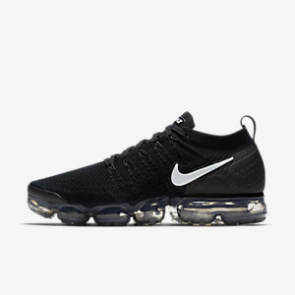

Product code: 1016

-With the latest Max Air innovation underfoot, the Nike Air VaporMax Flyknit 2 Men's Running Shoe brings fresh design elements. More support around the heel pairs with the foot-hugging feel of Flyknit. The futuristic sole completes the package, for a shoe that's as ready for your quick run as it is for an elevated look.

Nike Odyssey React

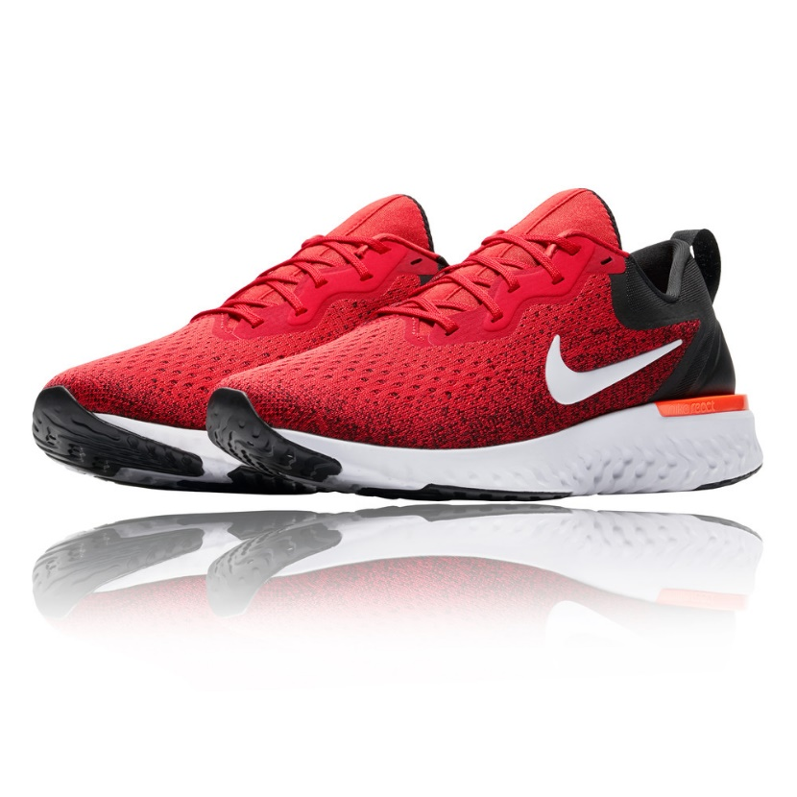

Product code: 1017

The Nike Odyssey React Men's Running Shoe provides crazy comfort that lasts as long as you can run. Its Nike React foam cushioning is responsive yet lightweight, durable yet soft. This attraction of opposites creates a sensation that not only enhances the feeling of moving forwards, but makes running feel fun, too. The upper of the Nike Odyssey React is built with a lightweight, breathable fabric instead of the premium Flyknit featured on the Nike Epic React.

Nike Zoom Fly

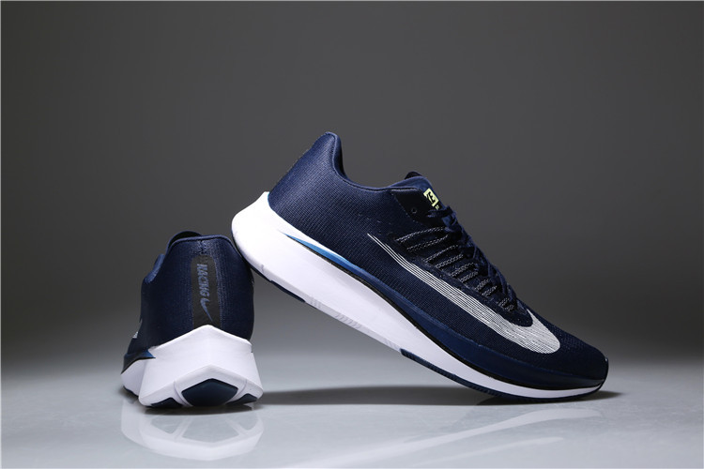

Product code: 1018

Built with a carbon-infused nylon plate inspired by the VaporFly 4%—our most efficient marathon shoe ever—the Nike Zoom Fly Men's Running Shoe is the perfect response to the demands of your toughest tempo runs, long runs and race days.

Nike Free RN Commuter 2017

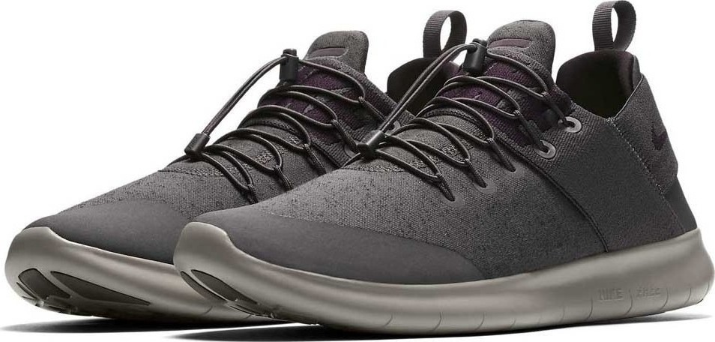

Product code: 1019

The Nike Free RN Commuter 2017 Men's Running Shoe adapts to your day. Perfect for a short run between work or errands, it features the ultra-flexible and innovative Free sole that lets your foot move naturally. Subtle branding lets the shoe blend in with your work wardrobe, so you don't have to carry an extra pair. If you need to change, its foldable design lets you quickly slide the shoe into a tote or backpack.

Jordan Zoom Tenacity

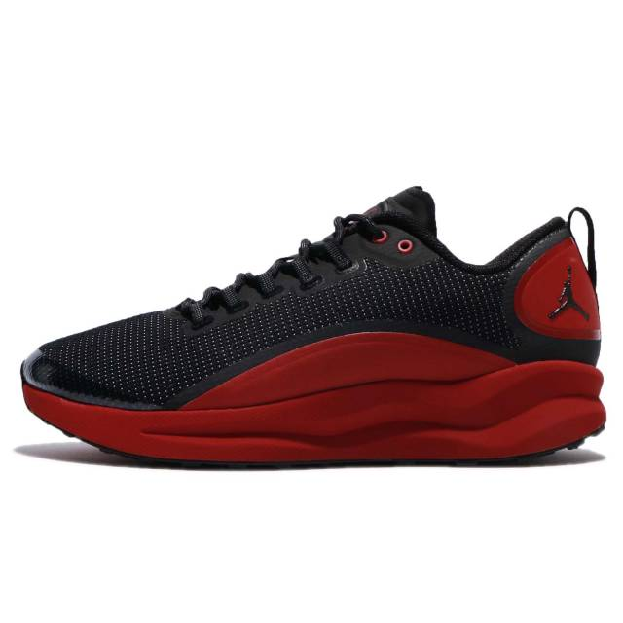

Product code: 1020

The Jordan Zoom Tenacity Men's Shoe offers responsive cushioning and lightweight comfort